Trimeter

📏 What is Trimeter
# Source: Chatgpt (GPT-4-turbo) at [8/2/2025]
Trimeter is a type of poetic meter that consists of three metrical feet per line. A "foot" is the basic unit of meter, made up of one stressed syllable and one or more unstressed syllables, depending on the foot type.

🧱 Structure
# Source: Chatgpt (GPT-4-turbo) at [8/2/2025]
- A line of trimeter has three feet, typically totaling 6–9 syllables, depending on the foot used.
- Common types include:
  - Iambic trimeter (da-DUM ×3)
  - Trochaic trimeter (DUM-da ×3)
  - Anapestic trimeter (da-da-DUM ×3)
  - Dactylic trimeter (DUM-da-da ×3)

📝 Example

Iambic Trimeter:
# Source: Chatgpt (GPT-4-turbo) at [8/2/2025]

The only news I know
Is bulletins all day
— Emily Dickinson

Trochaic Trimeter:
# Source: Chatgpt (GPT-4-turbo) at [8/2/2025]
Running down the forest,
Leaping over shadows.

🧬 Variants
# Source: Chatgpt (GPT-4-turbo) at [8/2/2025]
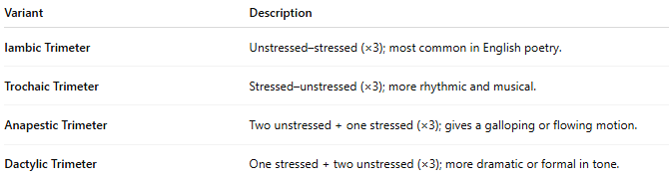
Variant | Description
Iambic Trimeter | Unstressed–stressed (×3); most common in English poetry.
Trochaic Trimeter | Stressed–unstressed (×3); more rhythmic and musical.
Anapestic Trimeter | Two unstressed + one stressed (×3); gives a galloping or flowing motion.
Dactylic Trimeter | One stressed + two unstressed (×3); more dramatic or formal in tone.

🎭 Effect in Poetry
# Source: Chatgpt (GPT-4-turbo) at [8/2/2025]
- Shorter than tetrameter or pentameter, so it's used to create:
  - Tension
  - Rapidity
  - Brevity
- Often used in dialogue, folk songs, and lyric poetry.

📚 Where It's Found
# Source: Chatgpt (GPT-4-turbo) at [8/2/2025]
- Common in:
  - Ballads
  - Greek drama (choral odes)
  - Hymns
  - Short lyric verse

